Problem Statement

# Product Dissection for top leading Platforms

Welcome to this case study on dissecting and designing products for top leading platforms. In this case study, you will delve into the intriguing world of schema design for a prominent platform of your choice. Your task is to choose a top leading platform, research its features, and meticulously craft a schema design that encapsulates the essence of its functionality. By focusing on key entities, attributes, and relationships, you will gain invaluable insights into how data architecture drives the platform's effectiveness.

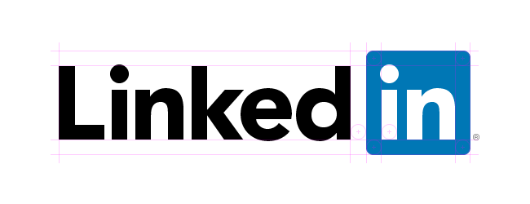

**Product Dissection for Linkedin**

### **Company Overview:**

**LinkedIn** is a business and employment-focused [social media platform](https://en.wikipedia.org/wiki/Social_media_platform) that works through websites and mobile apps. It was launched on May 5, 2003.Since December 2016, it has been a wholly owned subsidiary of [Microsoft](https://en.wikipedia.org/wiki/Microsoft). The platform is primarily used for professional networking and career development, and allows jobseekers to post their [CVs](https://en.wikipedia.org/wiki/Curriculum_vitae) and employers to post jobs.

LinkedIn's current CEO is [Ryan Roslansky](https://en.wikipedia.org/wiki/Ryan_Roslansky). LinkedIn reached profitability in March 2006.Since January 2011 the company had received a total of $103 million (~$133 million in 2022) of [investment](https://en.wikipedia.org/wiki/Investment).

### **Product Dissection and Real-World Problems Solved by LinkedIn:**

LinkedIn, a global social media phenomenon, has effectively addressed real-world challenges through its innovative product offerings.The basic functionality of LinkedIn allows users to create profiles, which for employees typically consist of a [curriculum vitae](https://en.wikipedia.org/wiki/Curriculum_vitae) describing their work experience, education and training, skills, and a personal photo. Employers can list [jobs](https://en.wikipedia.org/wiki/Job) and search for potential candidates. Users can find jobs, people and business opportunities recommended by someone in one's contact network. Users can save jobs that they would like to apply for. Users also have the ability to follow different companies.

The site also enables members to make "connections" to each other in an online social network which may represent real-world professional relationships.

A member's list of connections can be used in a number of ways. For example, users can search for second-degree connections who work at a company they are interested in, and then ask a specific first-degree connection in common for an introduction. The "gated-access approach" (where contact with any professional requires either an existing

relationship, or the intervention of a contact of theirs) is intended to build trust among the service's users.

Users can interact with each other in a variety of ways:

* Connections can interact by choosing to "like" posts and "congratulate" others on updates such as birthdays, anniversaries and new positions, as well as by direct messaging.
* Users can share video with text and filters with the introduction of LinkedIn Video.
* Users can write posts and articles within the LinkedIn platform to share with their network.

"LinkedIn is, far and away, the most advantageous social networking tool available to job seekers and business professionals today".

### **Case Study: Real-World Problems and LinkedIn Innovative Solutions**

LinkedIn, a leading social media platform, has not only revolutionised the way we share and consume content but has also addressed significant real-world challenges through its innovative features.

#### **Problem 1: Common challenges of job seekers**

**Real-World Challenge:** Job seekers face a number of common challenges, including confusing application processes, unclear job descriptions, long drawn-out interview processes, online resume filters, the hidden job market, and feeling like they’re not qualified for a role.

Applying for jobs can be a daunting task, but with the right attitude and knowledge, you can make it an exciting experience.

**LinkedIn Solution:** LinkedIn can help job seekers in several key ways. LinkedIn works by allowing you to create a profile to highlight your skills and work experience, apply to jobs directly (including using Easy Apply to submit your resume in just a few clicks), network with peers, and even directly message recruiters and hiring managers about job openings.

LinkedIn members can also upload past work examples to create a portfolio, collect recommendations from colleagues to show hiring managers why they’re a great candidate, and more.All of these factors will help you gain job opportunities, making LinkedIn an essential tool when job hunting.

**Problem 2: Keeping skill sets according to current job market**

**Real-World Challenge:** The job market is constantly evolving, and it’s important to keep up with changing trends in order to remain competitive.

**LinkedIn Solution:** LinkedIn recognizes the dynamic nature of the job market and is committed to helping professionals stay ahead by providing tailored resources and features. The platform will enhance its educational content, offering regular updates on industry trends, job market insights, and skill development opportunities. Additionally, LinkedIn will implement targeted notifications and reminders to prompt users to engage with these resources, ensuring that professionals are well-informed and equipped to navigate the evolving job landscape. This proactive approach aims to empower users, encouraging them to take advantage of the platform's educational offerings and stay competitive in their respective fields.

**Problem 3: Hiring Challenges Recruiters Face**

**Real-World Challenge:** There’s too much noise in the market, making it hard to grab a candidate's attention. There's a shortage of talent with the skills your company needs.

**LinkedIn Solution::** Build a strong [employer brand](https://www.linkedin.com/business/talent/blog/talent-acquisition/employer-branding) that makes great candidates chase your company, rather than the other way around.

Here are lots of ways to build your brand on any budget, from sharing the stories of real employees on social media to creating stand-out LinkedIn Career Pages. The goal is to show candidates how your company can help them find purpose and grow their careers. That way, if they do some research after you reach out or they click through a link you’ve sent them, they’ll get a sense of what makes your company unique — encouraging them to respond.

Use data to find the best places to recruit. Tools like LinkedIn Talent Insights can help you determine where to focus your recruiting efforts by showing you areas where there is short supply and lots of competition for talent — and more importantly, places where supply exceeds demand.

For example, if you were looking for recent college grads with engineering skills, you might discover that the West Coast has the highest density of this talent. With this information, you can make strategic recommendations to your leaders, like enticing candidates to relocate or even developing a remote work program.

**Problem 4: Networking in job market**

**Real-World Challenge:** Networking is an effective tool that enables job seekers to find opportunities, stand out in a crowded job market, and ultimately secure their dream job

**LinkedIn Solution:** Networking has always been a powerful tool for professionals, but with the rise of social media platforms like LinkedIn, the opportunities to connect and build meaningful relationships have expanded exponentially. LinkedIn, the world's largest professional networking platform.

It is an important aspect of career development and can help individuals to expand their knowledge, opportunities, and connections. Professional networking can take many forms, including attending industry events, participating in online communities, joining professional associations, and seeking out mentorship or coaching.

**Conclusion:**

The LinkedIn app stands as a powerful tool in the contemporary professional landscape, serving as a dynamic platform that facilitates meaningful connections, career advancement, and access to valuable industry insights. With its commitment to staying abreast of evolving job market trends and providing tailored educational content, LinkedIn empowers users to proactively manage their careers. By leveraging the platform's features, professionals can broaden their networks, explore new opportunities, and continuously enhance their skills, ultimately contributing to a more dynamic and interconnected global workforce. As LinkedIn continues to evolve and adapt to the changing needs of professionals, it remains a central hub for career development, networking, and staying informed in today's competitive professional arena.

### **Top Features of LinkedIn :**

1. **Profile Creation :** Users can create detailed professional profiles, highlighting their education, work experience, skills, and accomplishments.
2. **Job Listings post :** LinkedIn is a popular platform for job seekers and recruiters. Users can search for jobs, receive job recommendations from the post done by recruiters, and apply directly through the platform.
3. **InMail:** LinkedIn's messaging system allows users to send InMail messages to connect with professionals outside their immediate network.
4. **Connection Building:** Users can connect with colleagues, classmates, industry professionals, and other individuals to expand their professional network.
5. **Comments :** Engagement lies at the heart of LinkedIn. Users can express appreciation by sharing their thoughts through comments.
6. **Like:** Engagement lies at the heart of LinkedIn . Users can express appreciation by liking posts.

### **Schema Description:**

The schema for LinkedIn involves multiple entities that represent different aspects of the platform. These entities include Profile Creation, Job Listings, InMail, Connection, Followers, Hashtags, and more. Each entity has specific attributes that describe its properties and relationships with other entities.

**Profile Entity:**

Users are at the core of LinkedIn. The user entity contains information about each user:

* **UserID (Primary Key)**: A unique identifier for each user.
* **Username**: The chosen username for the user's account.
* **Email**: The user's email address for account-related communication.
* **Full_Name**: The user's full name as displayed on their profile.
* **Bio**: A brief description that users can use to express themselves.
* **Registration_Date**: The date when the user joined LinkedIn.

**Job Post Entity:**

Posts capture the visual content shared on the platform:

* **PostID (Primary Key):** A unique identifier for each post.
* **UserID (Foreign Key referencing User Entity**): The user who created the post.
* **Caption**: Text accompanying the post, providing context.
* **Image_URL**: The URL of the image or video content.
* **Post_Date**: The date when the post was created.

**Comment Entity:**

Comments enable users to engage in conversations around posts:

* **CommentID (Primary Key)**: A unique identifier for each comment.
* **PostID (Foreign Key referencing Post Entity):** The post being commented on.
* **UserID (Foreign Key referencing User Entity)**: The user who posted the comment.
* **Text**: The text of the comment.
* **Comment_Date**: The date when the comment was posted.

**Like Entity:**

Likes represent user appreciation for posts:

* **LikeID (Primary Key):** A unique identifier for each like.
* **PostID (Foreign Key referencing Post Entity):** The post being liked.
* **UserID (Foreign Key referencing User Entity):** The user who liked the post.
* **Like_Date:** The date when the like was registered.

**Follower Entity:**

Followers establish connections between users:

* **FollowerID (Primary Key)**: A unique identifier for each follower relationship.
* **Following UserID (Foreign Key referencing User Entity)**: The user who is being followed.
* **Follower UserID (Foreign Key referencing User Entity)**: The user who is following.
* **Follow_Date**: The date when the following relationship was initiated.

**InMail Entity:**

Allows users to send E-Mail messages to connect:

* **EMAIL ID (Primary Key):** A unique identifier for each user.
* **EMAIL UserID (Foreign Key referencing User Entity)**:The user who sends the Email.
* **EMAIL_Date**: The date when the Email was received.

**Relationships are:**

* **Users Posts –** Users can post multiple posts like hiring posts, achievements posts, and each post can have multiple comments.
* **Users** comments **Posts –** Users can comment on multiple posts, and each post can have multiple comments.
* **Users like Posts –** Users can like multiple posts, and each post can have multiple likes.
* **Users follow other Users –** Users can follow multiple users and be followed by multiple users.
* **InMail –** User can send emails to connect with professionals outside their immediate network

**ER Diagram:**

Let's construct an ER diagram that vividly portrays the relationships and attributes of the entities within the LinkedIn schema. This ER diagram will serve as a visual representation, shedding light on the pivotal components of LinkedIn data model. By employing this diagram, you'll gain a clearer grasp of the intricate interactions and connections that define the platform's dynamics.

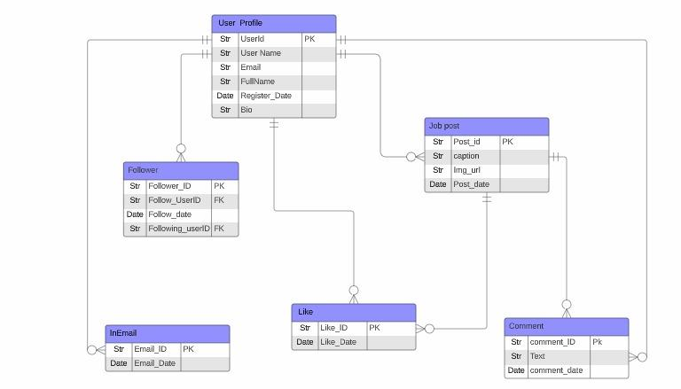

### **Conclusion**

In this case study, we delved into the design of LinkedIn schema and Entity-Relationship diagram. LinkedIn has revolutionised the way people share and engage with connections. The platform's intricate data model, consisting of entities like users, posts, comments, likes, and connections, forms the foundation for its seamless functionality. By understanding this schema, we gain insight into how LinkedIn effectively manages the complexities of hiring candidates by recruiters and finding jobs for jobseekers and contributing to its widespread popularity and continued growth in the world of social media.

Group Members :

Pratik Phale

Shweta Dhore